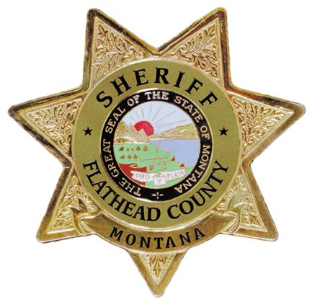

BRIAN HEINO SHERIFF / CORONER

**FLATHEAD COUNTY**

920 SOUTH MAIN STREET, STE 100, KALISPELL MONTANA

PHONE: 406-758-5585 FAX: 406-758-2420

***SHERIFF’S OFFICE***

FOR IMMEDIATE RELEASE

Pre-Evacuation Warning Rescinded – East Fork Fire

Olney, MT – Wednesday, August 30, 2023 @ 01:00 p.m.

Flathead County Sheriff Brian Heino in coordination with Northern Rockies Complex Incident Management Team 6 has deemed that the imminent risk of danger to life and properties in the vicinity of the East Fork Fire has diminished at this time.

The Pre Evacuation Warnings issued on August 17, 2023, and August 20, 2023, are rescinded, and will be effective at 01:00 p.m. on Wednesday, August 30, 2023. A Pre-Evacuation Warning may need to be reissued if the risk of danger to life and property should again warrant such action.

For more information, please visit <https://flathead.mt.gov/department-directory/oes/emergency-management/east-fork-fire-information> or call the Flathead County Office of Emergency Services Public Information Line at 406-758-2111.